Khan Academy Video Clip: Unbalanced Forces and Motion
Watch the video clip and complete the guided notes.
1. Before watching, predict whether each of the following statements is true or false:
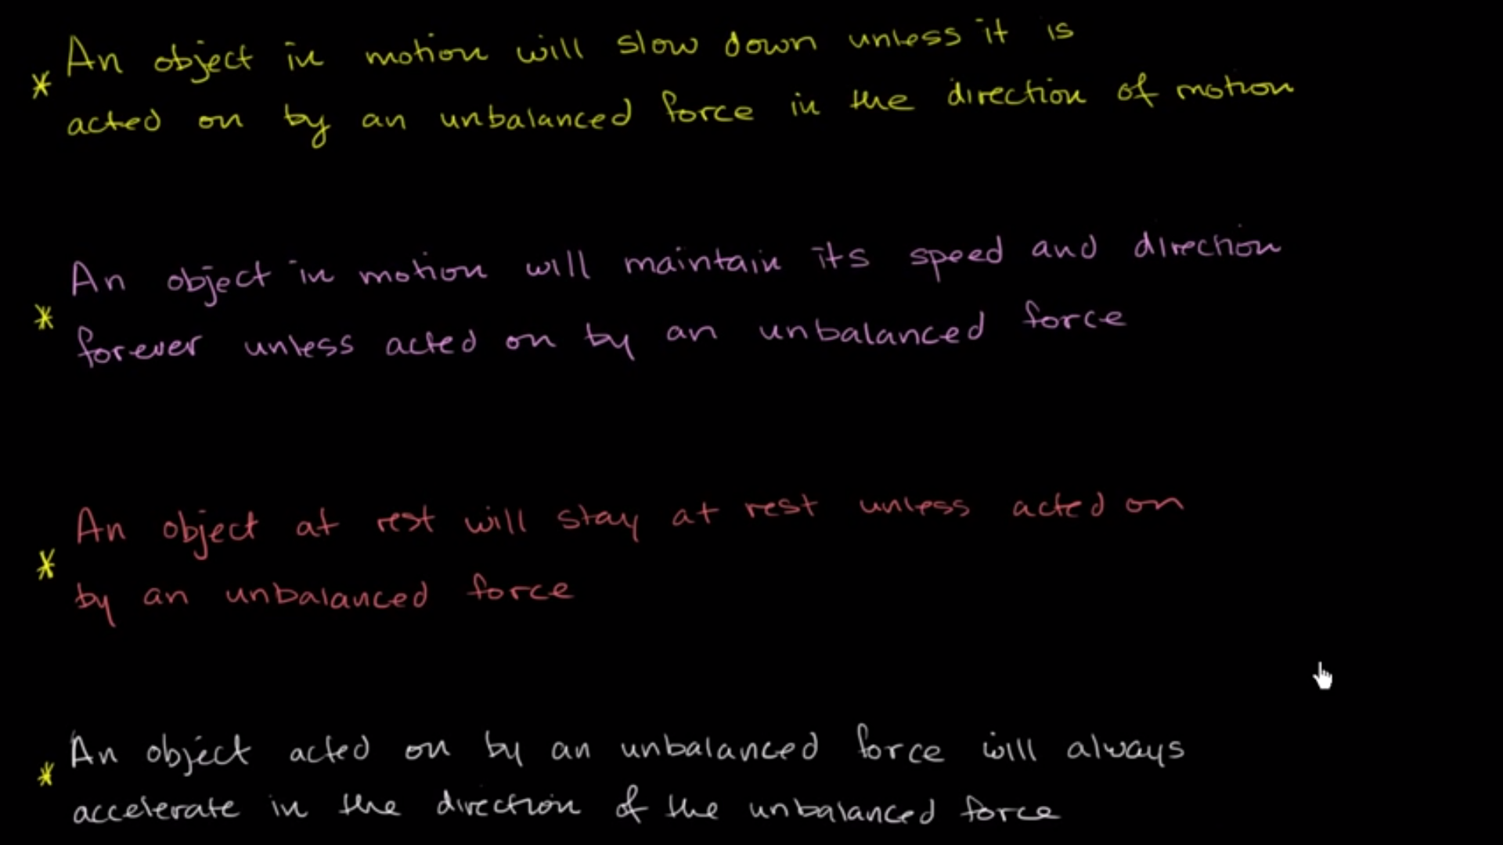

2. Is the following statement true or false? Explain.

3. Is the following statement true or false? Explain.

4. Is the following statement true or false? Explain.

5. Is the following statement true or false? Explain.

