**PhET Simulation: Forces and Motion Basics – Acceleration**

Open the following link:

<https://phet.colorado.edu/sims/html/forces-and-motion-basics/latest/forces-and-motion-basics_en.html>

Click on “Acceleration.”

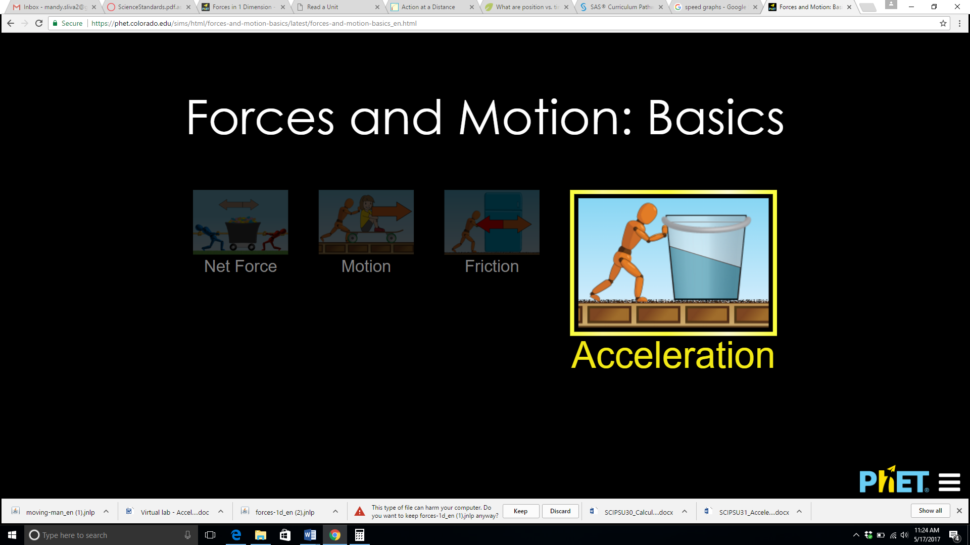

The brown crate is the default load and the orange robot is the pusher. Notice that you can add mass by adding the refrigerator, a bucket of water, or even people to the load. In the top right pane, make sure there are check marks in the boxes for forces, values, masses, speed, and acceleration.

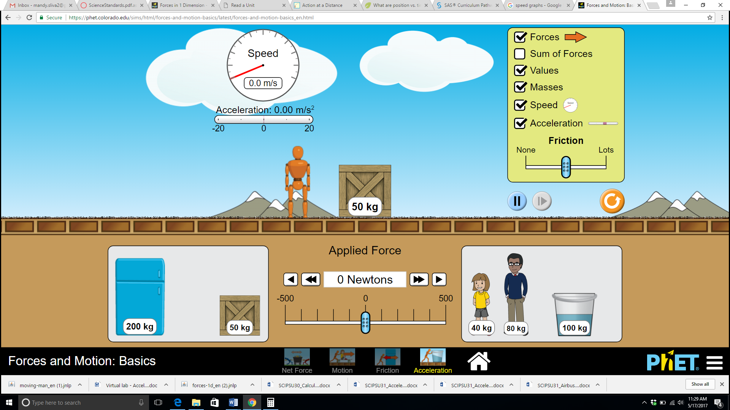

You can start things moving in one of two ways: click and drag the robot to the right or left to generate enough force to move the crate, or manipulate the sliding bar to the left or right to get it going.

*Generate enough force to make the crate start moving to the right, then let go. What happens to the crate’s speed and acceleration before, during, and after the force was applied?*

*Add more mass to the load, then apply a force to get it moving. What do you notice compared to the first trial?*

*Play around with the simulation. Try using a smaller or heavier load, greater or less forces, and see how they affect the object’s acceleration. Type a summary based on your observations.*