**SCIENCE PHYSICAL SCIENCE UNIT 20**

**Solubility Lab: Which Substance is the Most Soluble in Water?**

Problem – You need to investigate which substance is the most soluble in water, among sodium chloride (table salt), sugar, and baking soda.

Question – Which substance is the most soluble in room temperature water: salt, sugar, or baking soda?

Hypothesis – write your own hypothesis to start your investigation.

Materials Needed –

hexagonal pencil (the flat sides are helpful) or pen

12-inch ruler

4 small paper cups such as Dixie cups (or make equal-sized paper trays if you don’t have cups)

3 larger cups such as drinking glasses, Solo cups, foam cups, etc.

20 paper clips, safety pins, small balls of paper, or other items with light mass to use as counter weights

marker or pen

tape

table salt

sugar

baking soda

water

spoon

water containment device (pitcher, large glass, etc)

1-cup measuring cup

Procedure –

1. Fill a pitcher or large glass with water to allow it to come to room temperature while you set up the rest of the lab. You will need at least 3 cups of water to complete the experiment.

2. Create a balance scale using the pencil, ruler, tape, small cups, and paper clips. Use the marker to label the small cups as “salt,” “sugar,” and “baking soda”. The unlabeled cup can be used for the paper clips/other counter weight. Tape the pencil to a flat surface, such as a table or countertop. Place the ruler on the pencil, and put a piece of rolled-up tape on each end of the ruler. Place the unlabeled cup on one end of the ruler, and the “salt” cup on the other end. Take time to make sure the ruler is balanced and then make a pencil mark on the ruler where it is directly over the pencil. Your balance scale should look similar to the ones below.

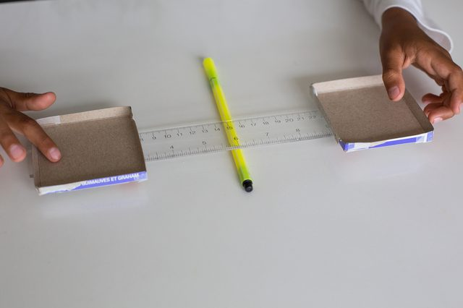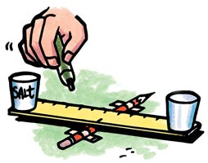

3. Gently place the paper clips into the unlabeled cup. Slowly add salt into the labeled salt cup until the scale is balanced.

4. Remove the salt cup from the ruler and replace with the sugar cup. Slowly add sugar until the scale is balanced. Repeat with the baking soda cup and baking soda.

5. Measure and pour 1 cup of water into each of the three larger cups.

6. Take the salt you just measured and pour into one cup of water. Note the appearance before stirring. Use the spoon to stir for 30 seconds and again note the appearance and how much salt has dissolved. Continue stirring for another 30 seconds and record your observations. Do this for a total of 2 minutes in 30-second intervals and record your observations each time.

7. Repeat step #6 for the sugar and baking soda. Work with one substance at a time so you can give it your full attention.

8. Take your collected data and analyze it.

Recording and Analyzing Data –

Salt in Water – Observations (use one row to draw and one row to describe)

|  |  |  |  |  |
| --- | --- | --- | --- | --- |
| Initial | 30sec | 1min | 1min 30sec | 2min |
|  |  |  |  |  |
|  |  |  |  |  |

Sugar in Water – Observations

|  |  |  |  |  |
| --- | --- | --- | --- | --- |
| Initial | 30sec | 1min | 1min 30sec | 2min |
|  |  |  |  |  |
|  |  |  |  |  |

Baking Soda in Water – Observations

|  |  |  |  |  |
| --- | --- | --- | --- | --- |
| Initial | 30sec | 1min | 1min 30sec | 2min |
|  |  |  |  |  |
|  |  |  |  |  |

Analysis Questions

Initially, which substance seemed to be the most soluble?

After a 2-minute time span, which substance seemed to be the most soluble?

After a 2-minute time span, which substance seemed to be the least soluble?

Were there any substances that dissolved fully before 2 minutes?

Conclusion – write a conclusion statement based on your experiment. Did you prove your hypothesis? What, if any, changes should be made if the experiment were conducted again?