**Innovations in Football Equipment: Football and Gloves**

**Introduction**

Due to recent advances in technology and engineering, new innovations in equipment are helping to support the game of football in every respect. Any objects that are kept and used together for a specific purpose can be called **equipment**. In football, equipment includes everything from the football itself to shoulder pads, jerseys and gloves. From the cleats that players wear to the actual shape of the football, engineers have applied their creativity, ingenuity and expertise to develop better football equipment in the pursuit of excellence.

**What is engineering and design?**

Football equipment has changed and improved dramatically over the years with the introduction of new materials and technology, which allowed players to perform at a higher level. To understand the recent advancements in engineering that have been used in professional football, first you have to understand what engineering is. **Engineering** involves the combining of multiple studies that you learn in school (math, technology, science, social studies, language arts and fine arts) to search for practical, dynamic and cost-effective ways to use materials to meet today's challenges.

Engineering can further be defined as creative efforts made to come up with a solution to a problem. **Design** is defined as the process of deciding how something will be made, including how it will work and what it will look like. Engineering and design go hand-in-hand. Many times the solution involves designing something that meets specific criteria or accomplishes a certain task. Design thinking and engineering knowledge and practice come together in many innovations found in professional football. Many seemingly simple aspects of our daily lives -- as well as various aspects in the game of football -- have been designed and created by engineers. **Engineers** are team players (much like football players) who dream up creative and practical solutions with the ability to change the world for the better. There are various ways to be an engineer, from designing software programs on a tablet for 49ers players to help them study game action, to overseeing maintenance operations for major structures like Levi’s® Stadium. A great deal of engineering work is done through the materials available to engineers and the technology that is present. There are a variety of engineering disciplines, and every day we see new disciplines emerge with the spread of new technologies.

[[Where can I learn more about materials in equipment design?]](javascript:void(0))

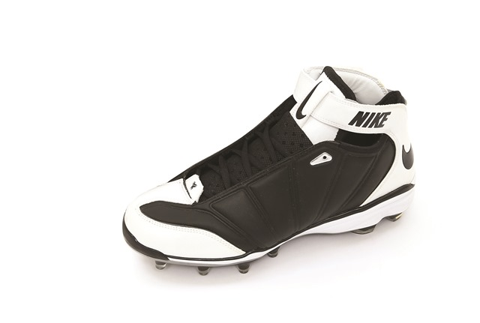

**Engineering design innovations lead to effective solutions to problems that arise in the use of equipment in professional football.**

**Sports engineering and the engineering design process**

As the popularity of football increased, so did the demand for the study of how football equipment performs, which dramatically increased the need for engineers in the football industry. The interest in applying engineering concepts to football ultimately led to the creation of a career field called sports engineering. **Sports engineering** is a field of engineering that involves the design, creation, testing and improvement of sports equipment. Professional football equipment used by the league has always gone through a vast amount of engineering development based on the most current research findings and the constant changes in how the game is played.

Sports equipment engineers are basically problem solvers who use every resource possible to bring what they formulate into the world of sports by going through a very important process, called the **engineering design process**. Every object you see - like the clothes you wear, the vehicles people drive, cell phones and the design aspects of the buildings we use - all went through the engineering and design process before being built. The engineering design process is made of many steps. These steps take place in a certain order, but they are part of a larger cycle that can be repeated. This process helps engineers find a better way to solve a problem or gives them a better direction to improve our world in some way. Below is a breakdown of the engineering design process:

**Step 1:** Identify the Problem – At this point in the process, engineers point out the problem that they need to solve.

**Step 2:** Identify Criteria and Constraints – Next, engineers understand the requirements (criteria) for the design by deciding what it must do (or not do). They also list any constraints, such as cost, time or materials.

**Step 3:** Brainstorm Possible Solutions– Next, engineers will use their collective team’s “brain power” to imagine possible solutions to their problem and sketch them out.

**Step 4:** Generate Ideas – In this step, engineers take the best ideas from their brainstorming session, develop them more thoroughly and draw them in detail. They figure out how each idea will work by itself and also how it will fit into the larger whole.

**Step 5:** Explore Possibilities – Generated ideas are shared and discussed among team members. The engineering team explores the pros and cons of each design idea and all the possibilities the solutions provide.

**Step 6:** Select an Approach – At this point of the process, engineers pick the design approach that will best solve the problem.

**Step 7:** Build a Model or Prototype – In this step, engineers use their chosen design to create a prototype or model. Engineers build the model with materials that can help them see how their design works in “real life” and test its success.

**Step 8:** Refine the Design – After testing the model, engineers will discuss how they could refine, or improve their prototype or design. This leads them back to the beginning of the process, which repeats until they come up with a design that effectively solves their problem.

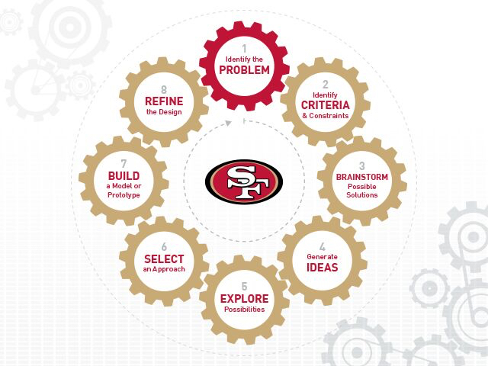

**Example of innovation: The football**

The first footballs were made of natural materials, such as an inflated pig bladder, which was later put inside a leather cover. This is why some still call the football "pigskin". Today's National Football League (NFL) footballs are made of cowhide leather. A inflated rubber bladder is what is on the inside of the ball, which is then covered by several layers of leather stitched together, then leather laces are added down one side of the ball to help with the grip of the ball. Modern balls are designed by teams of engineers to exact specifications, with rubber or plastic bladders, and often with plastic covers. They're oblong spheres, 11 to 11.5 inches (27.9 to 29.2 centimeters) long and weighing between 14 and 15 ounces (397 to 425 grams). A valve is on the outside of the ball so you can pump air more easily into the ball's bladder.

Once players and coaches realized the yardage that could be gained by completing a forward pass, teams began promoting the play. The passing game influenced design changes in the football. It evolved from a watermelon shape to a more aerodynamic **prolate spheroid** -- basically a watermelon shape with pointier ends. The laces, which originally were made just long enough to close the football after the bladder was inserted, became longer and more pronounced to aid players in gripping the ball.

**Example of innovation: Gloves**

The inventor of the football glove was John Tate Riddell, and was invented in 1939. When football gloves were first invented, they were used for cold weather and now they're mostly used for grip and protection. Football gloves have now improved in durability, **moisture wicking** (cloth that draws sweat off the skin to the outside of the fabric) capabilities, and in their ability to stick a grab onto a football. Many receivers wear gloves that either have a sticky rubber palm, called tact gloves, so they can have a better opportunity to catch a ball that is thrown by the quarterback. Linemen also wear gloves for protection. Lineman's gloves have thick padding in them to better protect their fingers and hands. In the past, it has been the practice to protect the hands of many football players, particularly linemen, by taping the hands with conventional adhesive tape, the tape runs across the back of the hand and across the palm. While this taping does offer some protection against injuries, it is less than satisfactory for providing maximum protection. With the invention of the glove, player’s hands have a maximum amount of protection while at the same time providing maximum freedom of movement. Modern sporting equipment engineers are making scientifically-based protective football gloves made out durable, super-light compounds that absorb impact forces and improve grip.

As you can see, the outcome of this continual cycle of innovation in the engineering of football equipment has driven research in material sciences and the use of stronger and more durable football equipment materials. Engineering is not only changing the equipment, but also changing the way the players and the game function.

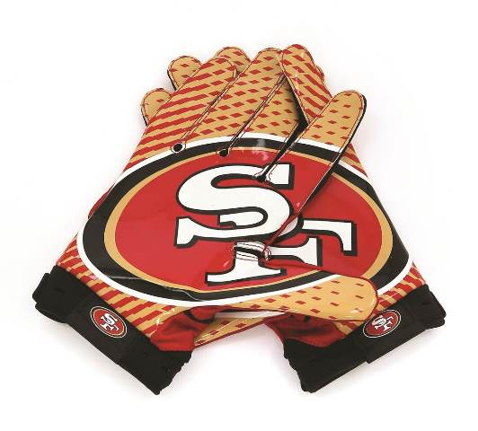

**Advancements in engineering and material technology have led to the**