Properties of Electromagnetic Waves
When we drop a stone in a pond, we see waves or ripples spreading out from the point where the stone was dropped. These waves are referred to as ___________________ waves. When you watch TV, listen to radio, or cook in a microwave, you are experiencing _______________ waves called ____________________ waves.
We know electricity can be _______________, meaning without movement. If we rub a balloon with a silk cloth and hold it to a wall, the balloon will stick to the wall because of static electricity. We also know that ____________________ can also be static, like refrigerator magnets.
When both electricity and magnetism move ________________, they cause ______________________ waves. Electromagnetic waves are made of both electric and magnetic waves. The _____________________, shown in blue color, moves perpendicular to the ____________________, shown in red color.

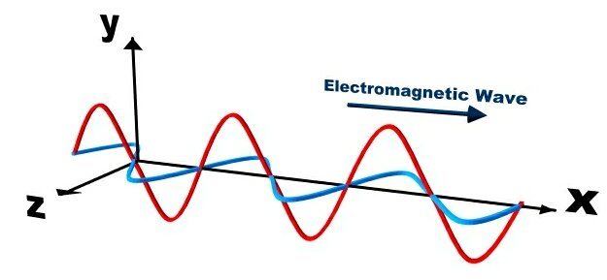

Both waves also move _______________________ to the direction of the wave. So electromagnetic waves are __________________ waves. Like mechanical waves, electromagnetic waves also have peaks called ______________, and _________________ called troughs. The distance between two crests or two troughs is called the ______________________. Unlike mechanical waves, electromagnetic waves don’t require a _______________ to travel through. Electromagnetic waves can travel through a _________________.
X-rays, ultraviolet rays, visible light, infrared, microwaves, and radio waves are all electromagnetic waves. All of these electromagnetic waves together are referred to as electromagnetic ______________________, that comes from outer space. Although all of the electromagnetic waves travel at the same ______________________, their ____________________ will differ. For example, ultraviolet rays have shorter wavelengths than radio waves. So more ultraviolet waves will pass a point in a given time than radio waves.

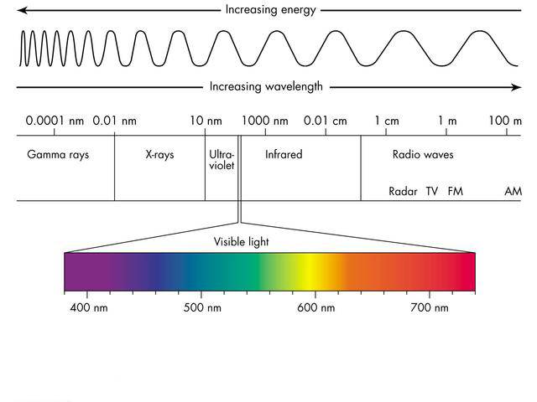
Summary:
- Electromagnetic waves are the combined movement of electricity and magnetism.
- Electromagnetic waves are transverse waves, and can travel through a vacuum.
- X-rays, light rays, radio waves, and microwaves are examples of electromagnetic waves.

