**JEFFERSON COUNTY EDUCATIONAL SERVICE CENTER**

**VIRTUAL LEARNING ACADEMY**

**BUOYANCY AND FLOW STUDENT WORKSHEET**

**SCIPHYSICS_APU23 SCIENCE PHYSICS AP**

**Part I: Archimedes Principle**

An object submerged wholly or partially in a fluid is buoyed up by a force equal to the weight of fluid it displaces.

**Go to**: <http://phet.colorado.edu/en/simulation/buoyancy>

**Start on the Intro screen on the Buoyancy Sim on the PhET Sims site and answer the following questions as you navigate through the simulate. Type your answers in the spaces below.**

1. 1. What is Archimedes Principle in your own words! Do not simply copy the above statement.
2. 2. What is the mass of each block?
3. 3. How much does each block weigh? (Use the formula and 9.8 m/s2 for g and ***show your work*** below. Then check the weight on the scale).
4. 4.Click box to “Show Forces” for “Gravity” and “Contact Forces” and click box to “Readout” for “Force Values”. What are the values of each force, for each block?

**Wood Block: Brick:**

Gravity:_________ Contact Force: _________Gravity:_________ Contact Force: _________

1. 5. What is the net force on each block?
2. 6. They are in a state of _________________. (word for equal forces on all sides)

1. 7. What is the volume of water in the pool?
2. 8. Place the wood block in the water. What volume of water does the wood displace?

1. 9. What is the weight of the water displaced? (Use the formula for the weight of a fluid above, show your work below)
2. 10. Click on the box to “Show Forces” for “Buoyant Force”. What is the value of the buoyant force?
3. 11. Compare the weight of the fluid displaced and the buoyant force.
4. 12. How much does the brick weigh?
5. 13. Place the brick in the pool, and let it sink. What volume of water does it displace?
6. 14. What is the weight of this water? (Use the formula and show your work below)
7. 15. What is the value of the buoyant force on the brick?
8. 16. Consider the weight of the wood and the buoyant force on the wood. Why doesn't it sink?
9. 17. Consider the weight of the brick and the buoyant force on the brick. Why does it sink?
10. 18. What is the density of the brick? of the wood? (Hint: Find the volume of the wood by holding it under water with the cursor)

Density of brick:________ Density of wood:_________

1. 19. What does density have to do with buoyant force?
2. 20. Remove the brick from the water and leave the wood in. Predict how much more water will be displaced when the brick is placed on the wood.

Prediction:____________

1. 21. Place the brick on the wood and record how much more water is displaced.
2. 22. Why must this much water be displaced in order for the system to float?

**Part II: Static Fluid Pressure and Fluid Flow**

**Objectives**

* Apply the concept of static fluid pressure to real world problems
* Investigate concepts of fluid flow

**Head to the following website to investigate fluid pressure. Click ‘Run Now!’**

<http://phet.colorado.edu/en/simulation/fluid-pressure-and-flow>

**Procedures:**

1. Click on the ‘Flow’ Tab
2. Mess around with the simulation for at least 2 minutes. Experiment with every variable you can until you are familiar with the simulation.
3. We’re going to talk about mass flow rate and volume flow rate, which are two ways to talk about fluids flowing.

**Setup**

1. Click on the ‘Reset All’ button

Mass flow rate, is the mass of the fluid passing through a pipe in a given second.

1. In physics, mass flow rate is measured in ___________________ .
2. Volume flow rate, , is the volume of the fluid passing through a pipe in a given second. What do you think volume flow rate is measured in in physics? _____________________.

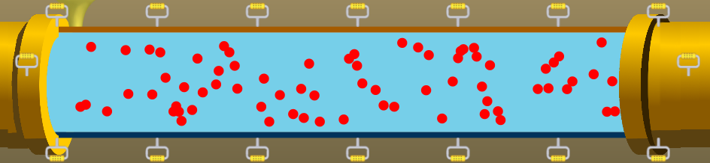

In the current simulation, the volume flow rate is 5000 L/s, or 5 m3/s. This means that 5 cubic meters of water are passing through the pipe in a second. If the density of this water is 1000 kg/m3, answer the following questions.

1. What is the volume of water that flows through the pipe in 6 seconds?
2. What is the mass flow rate of the water?
3. What is the mass of the water that flows through the pipe in 6 seconds?
4. The mass flow rate and the volume flow rate are always the same in a closed pipe. Why do you think that has to be the case? (Try and think about what might happen if the rates were not the same).

Section 2:

Setup

1. Select the ‘Flux meter’ option
2. Drag the pipe so that you have areas of 7 m2, 6 m2, 5.0 m2, 2.5 m2, and 1.0 m2
3. What do you notice about the volume flow rate at different points along the pipe?
4. What do you notice about the speed of the water at different points along the pipe? When is the water the fastest? The slowest?
5. Use the simulation to fill in the table below.

|  |  |  |
| --- | --- | --- |
| Area  (m2) | Speed  (m/s) | Volume Flow Rate  (m3/s) |
| 1.0 |  |  |
| 2.5 |  |  |
| 5.0 |  |  |
| 6.0 |  |  |
| 7.0 |  |  |

1. Write a statement describing the relationship between area and speed and volume flow rate.
2. How might your answer to number ten relate to the relationship between pressure and area that we learned about in unit 21. (talk about force in your answer)
3. Determine the speed at which water would flow through a point in the pipe that has a cross sectional area of 0.25 m2 and a volume flow rate of 5.0 m3/s. where AV (volume flow rate) is equal to the area times the speed of the fluid. Or **AV = A2v2.**
4. Determine the speed at which water would flow through a point in the pipe that has a cross sectional area of 0.25 m2 and a volume flow rate of 10.0 m3/s.
5. Determine the speed at which water would flow through a point in the pipe that has a cross sectional area of 1.0 m2 and a volume flow rate of 10.0 m3/s.
6. Determine the speed at which water would flow through a point in the pipe that has a cross sectional area of 1.0 m2 and a volume flow rate of 20.0 m3/s
7. Based on your answers to numbers 12 – 15, does this explain your conclusion about area vs. speed and flow rate that you described in #10?