**Jefferson County Educational Service Center**

**Virtual Learning Academy**

**SCIPHYSICS_AP**

**Student Worksheet Unit 16**

**MOMENTUM LAB**

**Part I- Elastics Collisions**

**Procedures**

1. Go to the website and run the simulation. <http://phet.colorado.edu/en/simulation/collision-lab>

2. The graph below is what you will see on the simulation page. Slide the elasticity bar all the way to the right.

3. Click on the more data button at the bottom of the simulation to change speeds easier.

4. You can control the velocity and direction of the balls by grabbing them and pulling them. You will see a green arrow which is your velocity vector, or you can control velocity and mass of the balls by typing the information into the data table.

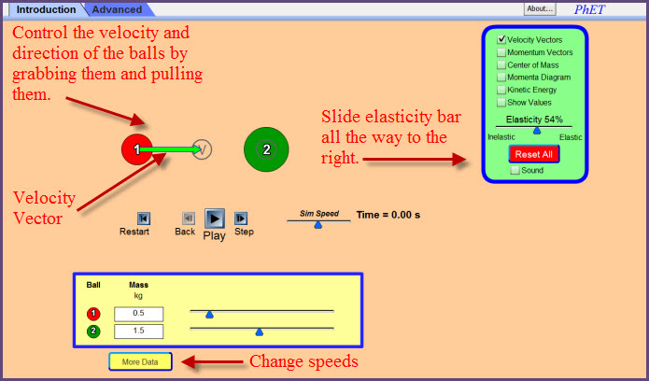

**Pre-Lab Questions –** answer the following before doing the simulation

1. What defines a collision as being elastic?
2. Simulate the four elastic collisions below. Complete the table using math formulas and the simulation.

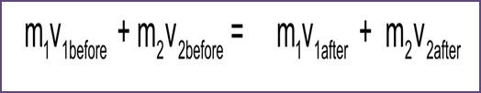

|  |  |  |  |  |  |  |  |
| --- | --- | --- | --- | --- | --- | --- | --- |
|  |  | | BEFORE COLLISION | | ptotal | AFTER COLLISION | |
| # | m1 | m2 | v1 | v2 | v1 | v2 |
| 1 | 2.0 kg | 2.0 kg | 1.5 m/s |  | 0 kg·m/s |  |  |
| 2 | 2.5 kg | 5.0 kg |  | -1.0 m/s | 0 kg·m/s |  |  |
| 3 | 3.0 kg | 6.0 kg | 2.0 m/s | 0.0 m/s |  |  |  |
| 4 | 6.0 kg |  | 2.0 m/s | -1.0 m/s | 8.0 kg·m/s |  |  |

**Part 1 Questions**

1. Two objects with the same mass move toward each other with the same speed and experience an elastic collision. Compare the final velocities of each object to their initial velocities.
2. A less-massive moving object has an elastic collision with a more-massive object that is not moving. Compare the initial velocity (speed and direction) of the less-massive object to its final velocity.

**Part II-Inelastic Collisions**

**Procedure**

**1. Use the same directions in part one except for change the elasticity slider all the way to the left so that the collision is completely inelastic.**

**Pre-Lab Question:**

1. What defines a collision as being inelastic?

1. Simulate the four inelastic collisions below. Complete the table using math formulas and the simulation. **Be sure to change the slider so that it is pointing on inelastic.**

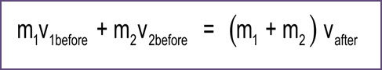

|  |  |  |  |  |  |  |
| --- | --- | --- | --- | --- | --- | --- |
|  |  | | BEFORE COLLISION | | ptotal | AFTER COLLISION |
| # | m1 | m2 | v1 | v2 | v1  v2 |
| 1 | 2.0 kg | 2.0 kg | 1.5 m/s | 0 |  |  |
| 2 | 3.0 kg | 6.0 kg | 1.5 m/s | -0.75 m/s |  |  |
| 3 | 1.5 kg | 5.0 kg | 2.0 m/s | 0.2 m/s |  |  |
| 4 | 10.0 kg |  | 2.0 m/s | -1.0 m/s | 10.0 kg·m/s |  |

**Part II Questions**

1. Two objects moving toward each other with different momentums experience an inelastic collision. In which direction will both objects travel after the collision?
2. A less-massive object is moving in the same direction as a more-massive object, but with a higher speed. They experience an inelastic collision. Describe the speed of the more-massive object after the collision.
3. Objects 1 has half the mass of object 2 and the objects move toward each other and experience an inelastic collision. If both objects do not move after the collision compare the velocity of both objects before the collision.
4. Show mathematically the total momentum before the collision in trial #1 is conserved after the collision.

**Calculation Questions:**

1. Calculate you kinetic energy’s before and after collisions for trial three of elastic and trial three of inelastic

2. From #1, which type of collision shows that kinetic energy is conserved?

3. Did your total momentum ever change? If so when?

**Conclusion Questions:**

1. A collision where both momentum and kinetic energy are conserved is an *elastic / inelastic* collision.
2. A 500 gram cart moving at **.**360 m/s has how much momentum? **(careful...units!)**

1. If the above 500 gram cart was to bounce back and return with a velocity of -**.**240 m/s, what is its change in momentum?

1. How fast must a 250 gram cart be traveling to have a momentum of .450 kgm/s?

1. A .230 kg baseball is thrown with a speed of 41 m/s. What is the ball’s momentum?

1. If the above ball comes to rest in the catcher’s mitt in .085 seconds, how much force does the ball apply on the catcher’s mitt? (hint: use the impulse-momentum theorem )

1. Imagine you are ice skating with your friend. Both of you are at rest, when you shove him/her away from you. You have a mass of 65 kg and he/she has a mass of 55kg. When you shove off, you move away with a velocity of -2.0 m/s. With what velocity does your BFF move away from you?
2. If a 250. gram cart moving to the right with a velocity of +.31 m/s collides inelastically with a 500. gram cart traveling to the left with a velocity of **-**.22 m/s, what is the total momentum of the system before the collision?
3. What is the resulting velocity of the above two-car system (stuck together)?
4. A 9.0 kg bowling ball races down the lane at 15 m/s before striking a bowling pin (at rest) with a mass of .85 kg. If the .85 kg pin bounces backward with a velocity of 45 m/s, what is the velocity of the bowling ball after the collision?
5. A 2.0 kg mass traveling at 3.0 m/s strikes another 2.0 kg mass traveling at -1.0 m/s. They collide and have a complete elastic collision. If the second mass moves at 3.0 m/s after the collision, what does the first mass do?
6. Let’s say you have a 1.0 kg mass at rest, struck by a 2.0 kg mass traveling at -2.0 m/s. They collide and stick together, thus combining their masses to 3.0 kg. What is the velocity of the combined mass and what type of collision is this?

**A look ahead**

In the next unit, we will be reviewing for the semester exam. You will be asked to complete a series of questions that we have covered in the previous units. This will help you to focus on the important concepts covered for the semester exam. You will have to recall information from the labs as well. It is a good idea to put together an equation sheet of all the equations that we have learned so far, so that answering the questions and problems will be easier and less time consuming.