PhET Simulation: Electric Field Hockey
Complete the following activity while interacting with the Electric Field Hockey simulation.
https://phet.colorado.edu/en/simulation/legacy/electric-hockey

First, make sure the “practice” mode is selected from the bottom. The space in between the puck and the goal will be wide open. The puck has a positive charge. Use the positive (red) and negative (blue) particles to create an electric field that will allow the puck to make it to the goal. Hit start when you are ready to test. You can hit reset and change the arrangement of particles as many times as you need. There are endless combinations to try, so have some fun with it!
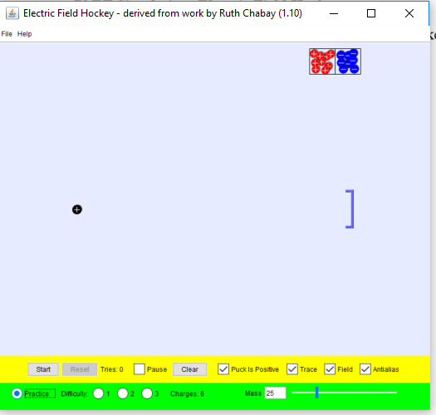

Now, hit clear and click on Difficulty 1. Repeat the exercise, trying to get the puck into the goal around one obstacle. Take a screen shot of your goal and add to this document.
(Include screen shot here)

Hit clear again and click on Difficulty 2. Repeat the exercise, trying to get the puck into the goal around two obstacles. Take a screen shot of your goal and add to this document.
(Include screen shot here)
Hit clear one more time and click on Difficulty 3. Repeat the exercise, trying to get the puck into the goal around three obstacles. Take a screen shot of your goal and add to this document.
(Include screen shot here)
Now answer the following questions.
1. What happens when you add a red or positive charge near the puck? Why do you think that happens?

2. What happens when you add a blue or negative charge near the puck? Why do you think this happens?

3. Explain the strategy you used to get the puck into the goal for each difficulty level.

